- March 16th 2019  Catholic WOmen’s Conference  Visitation: Fellowship and the Feminine Genius  8 to 4  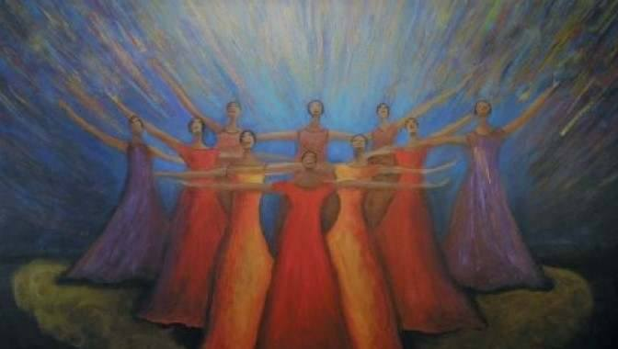  Spend a day with fellow faith-filled women exploring Catholic women’s unique role. Our keynote speaker, Abigail Favale, author of Into the Deep will share her journey from feminism to Catholicism and discuss how our faith informs our unique voice as women. Inspirational speaker Lynda Olsen will explore John Paul II’s Theology of the Body and how it can be lived in a practical way. Located at The Grotto, women will have plenty of time for fellowship, prayer and meditation. Complimentary access to the Upper Gardens, discount at The Grotto Giftshop, breakfast and lunch included. Go to our website for more information and registration https://thegrotto.org/event/catholic-womens-conference-visitation-fellowship-and-the-feminine-genius/ | Mass @ 8am  ____  Complimentary access to upper gardens  ____  Adoration @ 3pm  ____  Breakfast and Lunch provided  ____  $50  ____  Engaging Speakers!  NE 85th and Sandy  Portland  503-254-7371  thegrotto.org  Contact  Amy (360)609-4218

